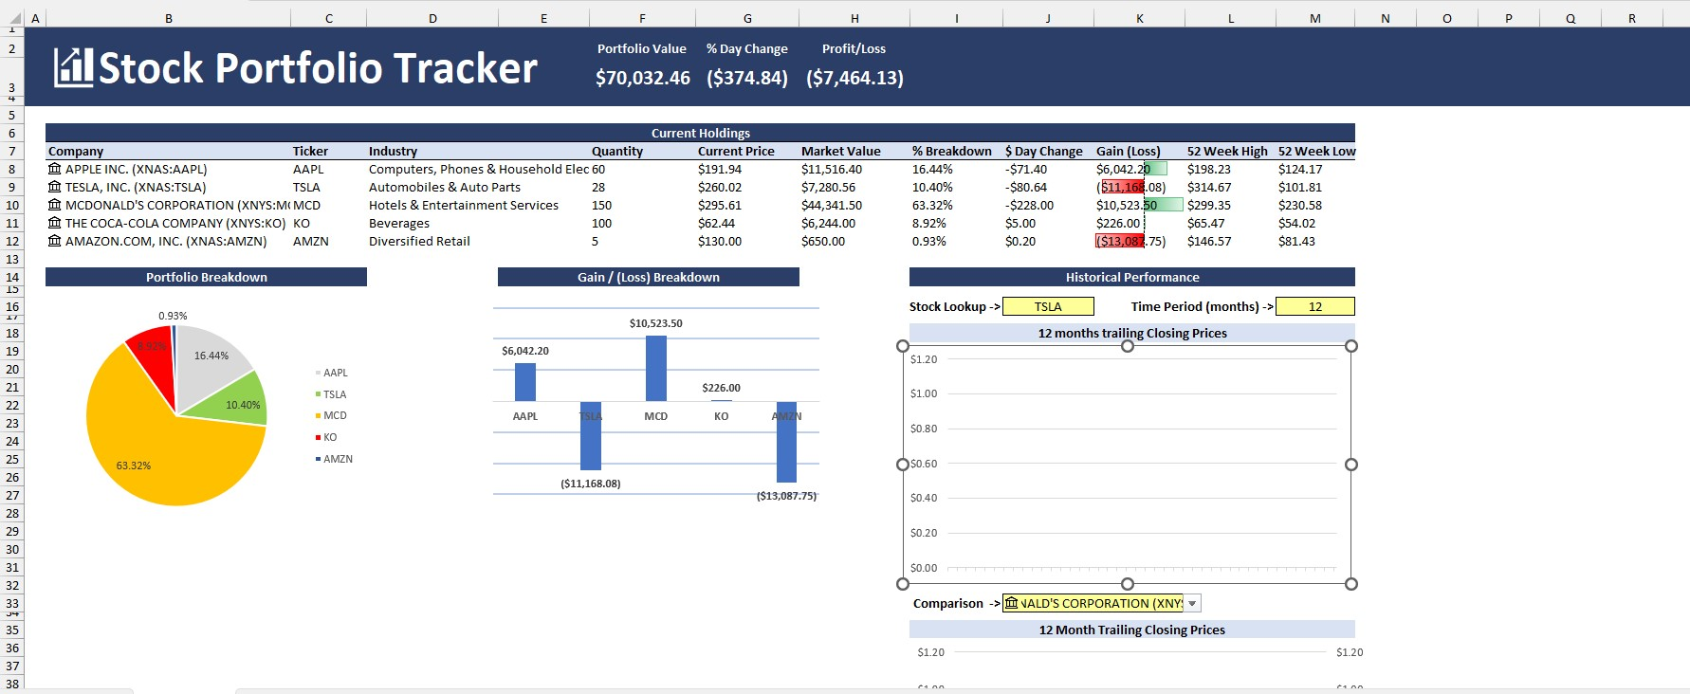**Stock Portfolio Tracker Dashboard**